Brute Force Feature matcher matches a feature from first set with every other in the other set

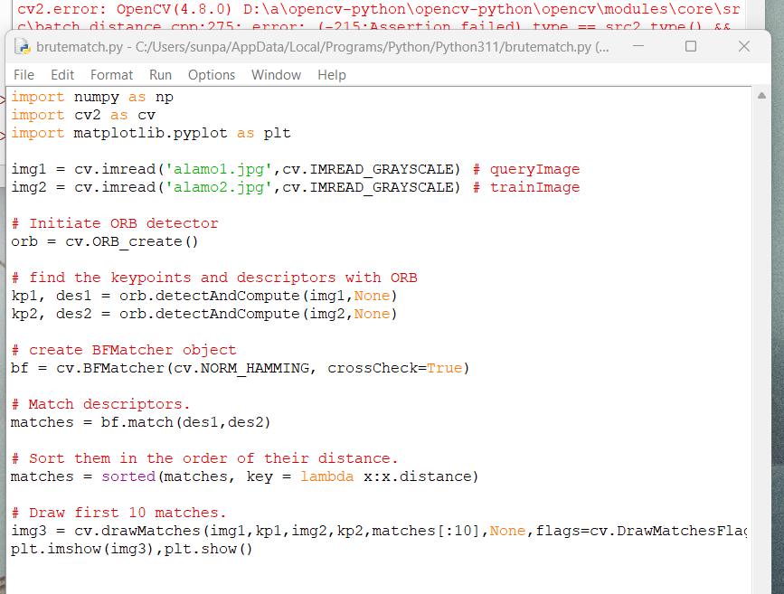

Code to create orb, detect keypoints, create BFM objected, match descriptors, sort by order of distance and draw first ten matches

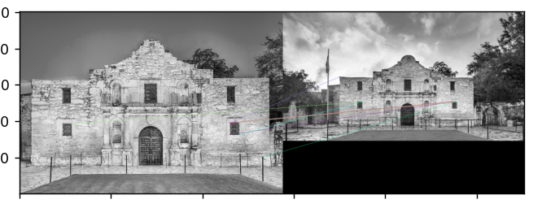

Difficult to see with the thinness of lines but matches drawn are somewhat accurate

FLANN based matcher

Fast library for approximate nearest neighbors

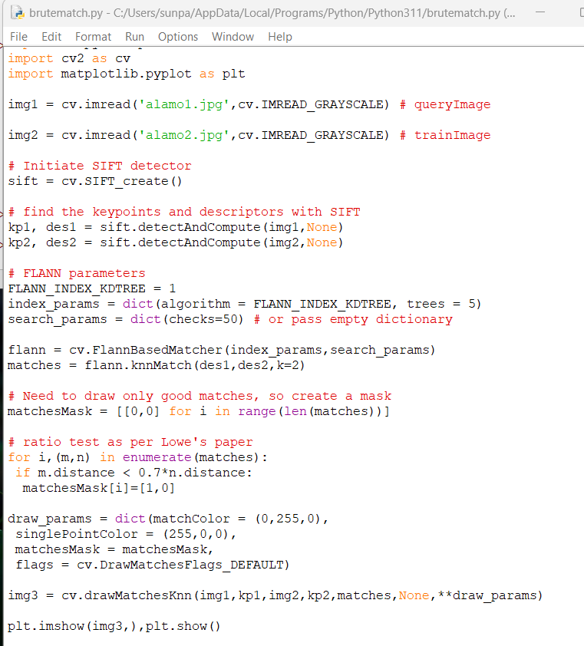

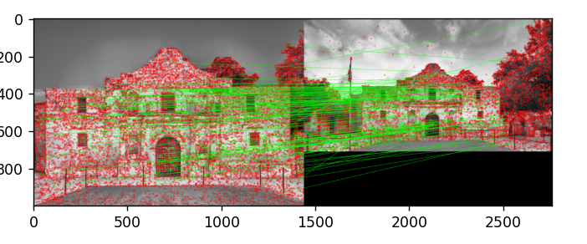

results